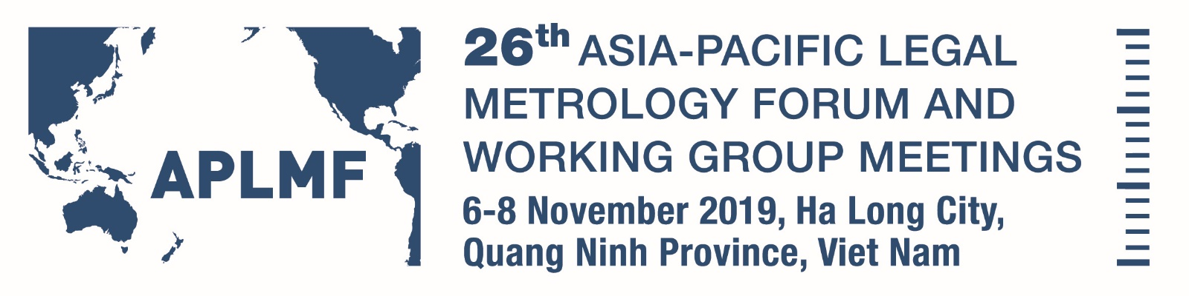

Wyndham Legend Ha Long Hotel

Hosted by Directorate for Standards, Metrology and Quality (STAMEQ)
Viet Nam
Programme
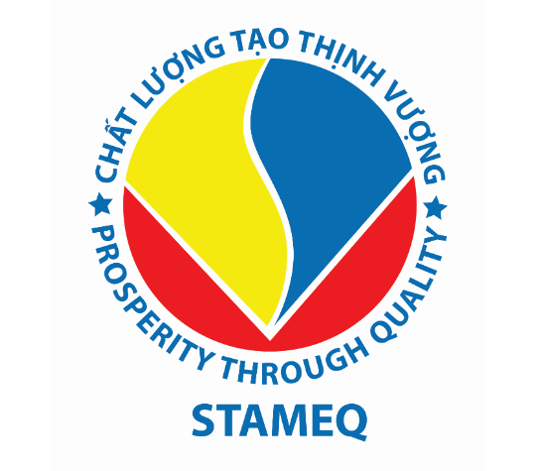

APLMF Working Groups Meeting

Date: Wednesday 6 November 2019

Time: 08:00 - 20:00

Venue: Wyndham Legend Ha Long Hotel, Diamond 1, 2nd Floor
Attending: Morning Session: Working Group members and observers
Afternoon Session: APLMF Secretariat, Executive Committee, Full Member Economies, Corresponding Member Economies, Observers, International and Regional Metrology organisations.
Chair: Stephen O’Brien

Time | Description | Facilitator/Speaker
08:00 - 08:45 | Registration | Secretariat & Hosts
08:45 - 09:00 | Welcome - Summary of day ahead | Mr Stephen O’BRIEN  Ms Alli SMITH
09:00 - 10:00 | Working Group Workshops  Note these workshops will be held in parallel.  - Goods Packed by Measure - Panorama 1 - 3rd Floor  - NAWI - Panorama 1 - 3rd Floor  - QMAP - Panorama 1 - 3rd Floor  - Utility Meters - Diamond 1 - 2nd Floor | Dr Rifan ARDIANTO  Ms Suliana GHAZALLI  Mr Surachai SUNGZIKAW & Ms Haslina bte Abdul KADIR  Mr WANG Lei
10:00 - 10:30 | Morning Tea
10:30 - 12:00 | Working Groups - Workshops continued
12:00 - 13:00 | Lunch and Registrations
13:00 - 13:15 | Welcome - Introductions and housekeeping | Mr Stephen O’BRIEN
13:15 - 13:45 | Secretariat Training Coordination Report | Mrs Marian HAIRE
13:45 - 14:00 | eLearning Training Modules  Update on Guide 8: How to develop an eLearning module | Mrs Marian HAIRE  Mr Phil Sorrell  Mr Guo Su
14:00 - 14:15 | MEDEA 2 Update  APLMF/PTB Memorandum of Understanding | Ms Corinna WEIGELT
14:15 - 14:30 | Working Group Report: Goods Packed by Measure | Dr Rifan ARDIANTO
14:30 - 14:45 | Working Group Report: Metrological Control Systems | Mr GUO Su
14:45 - 15:00 | Working Group Report: NAWI | Ms Suliana GHAZALLI
15:00 - 15:30 | Afternoon Tea
15:30 - 15:45 | Working Group Report: OIML Certificate Systems | Mrs ZHENG Huaxin
15:45 - 16:00 | Working Group Report: Quality Measurement of Agricultural Products | Mr Surachai SUNGZIKAW
16:00 - 16:15 | Working Group Report: Utility Meters | Mr WANG Lei
16:15 - 16:30 | Subject Matter Expert Report: Medical Measurement | Mr Jin-Hai YANG
16:30 - 17:00 | Promoting Legal Metrology to the Public in Indonesia | Dr Rifan ARDIANTO
17:00 -17:15 | Closing Remarks, Announcements | Mr Stephen O’BRIEN  Ms Alli SMITH
18:00 - 20:00 | Welcome Dinner  Wyndham Legend Ha Long Hotel, Panorama 2, 3rd Floor  Hosted by APLMF

26th Asia-Pacific Legal Metrology Forum Meeting

Date: Thursday 7 November 2019

Time: 08:30 - 20:30

Venue: Wyndham Legend Ha Long Hotel, Diamond 1, 2nd Floor

Attending: Representatives of APLMF Secretariat, Executive Committee, Full Member Economies, Corresponding Member Economies, Observers, International and Regional Metrology organisations.
Chair: Mr Stephen O’Brien Co-Chair: Mr TRAN Van Vinh

Time | Description | Facilitator/Presenter
08:30 - 09:00 | Registration | Secretariat & Hosts
09:00 - 09:35 | Welcome Addresses: Viet Nam  Leader of Ministry of Science and Technology  and  Leader of Quang Ninh People’s Committee | Mr TRAN Van Tung  Deputy Minister  Ms VU Thi Thu Thuy  Vice Chairman
09:35-09:45 | APLMF President’s Welcome | Mr Stephen O’BRIEN
09:45-10:00 | Official Group Photo - Lobby
10:00-10:20 | Morning Tea
10:20 - 10:45 | Report on APLMF 2019 Work Programme and Secretariat Activities | Mr Stephen O’BRIEN
10:45 - 11:00 | 2020 Working Group Action Plans | Mrs Marian HAIRE
11:00-11:05 | Poster Session Instructions | Ms Alli SMITH
11:05 - 11:30 | Poster Session 1  Australia  Japan  Philippines  United States of America | Mr Darryl HINES  Dr Tsuyoshi MATSUMOTO Ms Mikuko HAMADA  Mr Paulo LEONES  Mr Ralph RICHTER
11:30 - 12:00 | Poster Session 2  Brunei Darussalam  Republic of Korea  Kiribati  Vietnam | Mr Azmi Abdul RAHIM  Ms Ji Yeon KIM  Mrs Tirenga TAUEA  Mr NGUYEN Hung Diep
12:00 - 13:00 | Lunch
13:00 -14:00 | Specialist Body Reports  - International Organisation of Legal Metrology (OIML) - update  - Asia Pacific Metrology Programme (APMP) - update  - PTB - Overview of activities in addition to MEDEA  - Asia Pacific Accreditation Cooperation (APAC) - update  - Association of Southeast Asian Nations (ASEAN) - update | Dr Charles EHRLICH  Dr Toshiyuki TAKATSUJI  Ms Corinna WEIGELT  Mr Vu Xuan Thuy  Mr KHLAUT Ousa
14:00 - 14:20 | Poster Session 3  Cambodia  Malaysia  Chinese Taipei | Mr KHLAUT Ousa  Mr Peter AGANG  Mr Chia-Hao HSU
14:20 - 14:40 | Poster Session 4  PR China  New Zealand  Thailand | Mr GUO Su  Mr Phil SORRELL  Mr Surachai SUNGZIKAW
14:40 - 15:00 | Poster Session 5  Indonesia  Papua New Guinea  Singapore | Dr Rifan ARDIANTO  Mr Joe PANGA  Mrs Faith TAN
15:00 - 15:30 | Afternoon Tea
15:30 - 15:50 | 2020 APLMF Work Programme | Mrs Marian HAIRE
15:50 - 16:10 | APMP Focus Group - Report backs  - Food Safety and Clean Water  - Energy Efficiency  - Medical Metrology  - Climate Change and Clean Air | Ms Haslina bte Abdul KADIR  Dr Toshiyuki TAKATSUJI  Mr Jin-Hai YANG  Mr Ji Hyun UM
16:10 - 16:45 | Panel Discussion – OIML Certification System  Mr Bill LOIZIDES - OIML  Mrs CAI Changqing - PR China (Issuer)  Dr DaeKyung KANG – Republic of Korea (Utiliser) | Mr Phil SORRELL
16:45 -17:05 | Proposed Regional Pilot Premarket Surveillance Project (Conformity to Type) | Mr Darryl HINES
17:05 - 17:15 | Wrap up and announcements | Mr Stephen O’BRIEN/Co-Chair
18:00 - 20:30 | Farewell (Hospitality) Dinner - Muong Thanh Hotel, Ha Long  Hosted by Quang Ninh People’s Committee :  - Speech by Leader of Quang Ninh People’s Committee;  - Presentations/speech by APLMF president; and  - Special performance prepared by Quang Ninh People’s Committee

26th Asia-Pacific Legal Metrology Forum Meeting
Full Member Only Session

Date: Friday 8 November 2019

Time: 09:00 - 11:00

Venue: Wyndham Legend Ha Long Hotel, Diamond 1, 2nd Floor

Attending: Full Members Only
Chair: Mr Stephen O’BRIEN
Time | Description | Facilitator/Presenter
09:00 - 11:00 | Introduction to Session  - Roll Call  - Welcome to new members Brunei Darussalam and Kiribati  - Secretariat Host/Presidency appointment/transition  - Discussion of host for 27th and 28th APLMF meetings  - Membership status changes  - Secretariat Interim Financial Report Jan – Sep 2019  - MOU and Rules of Procedures – proposed update  - Draft 2020 Budget  - Strategic Plan 2020-2025  - 26th APLMF Resolutions | Mr Stephen O’BRIEN and Secretariat
Time: 11:30 - 18:00

Venue: Wyndham Legend Ha Long Hotel, Diamond 1, 2nd Floor

Attending: APLMF Secretariat, Executive Committee, Full Member Economies, Corresponding Member Economies, Observers, International and Regional Metrology organisations.
Chair/Co-Chair: Mr Stephen O’BRIEN/Mr TRAN Van Vinh
Time | Description | Facilitator/Presenter
11:00 - 11:30 | Morning Tea
11:30 - 12:30 | Other Business  -27th APLMF & WG – Host Economy  -28th APLMF & WG – Host Economy | Mr Stephen O’BRIEN
12:30 - 13:00 | Closing remarks by Co-Chair/Host Economy  Closing remarks by President
13:00 | Lunch
14:00 - 17:00 | Cultural Tour of Ha Long Bay (cruise)
17:15 - 18:00 | Transport back to hotel

